NEWSLETTER No. 34 - September

# Invite to GM and AGM

Our Annual General Meeting will be held at the Club, on Thursday the 2nd October commencing after the General Meeting which starts at 7.30pm. More details will be provided in a later Bulletin.

Each member is invited to attend. Nomination for Committee positions need to be received by close of business on Thursday the 25th of September either by email to [secretary@schvc.com.au](mailto:secretary@schvc.com.au) or by post at:

SCHVC Inc. PO Box 219 Pambula NSW 2549.

# Roadster and Bike Run

## Event Information

**Date:** Sunday, 28th September 2025  
**Meeting Time:** 11:00am  
**Meeting Point:** The Club

## What to Expect

* Scenic ride for bikes and roadsters – Nethercote Myrtle Mountain Candelo
* Friendly social atmosphere - all are welcome.
* Lunch at Candelo Café

## Line drawing of a vintage classic roadster car, open top with wire wheels and front grille.Reminders

* Please bring your helmet and riding essentials.
* Arrive promptly at 11:00 am at the Club to join the group leaving at 11:30 am
* The event is family-friendly and suitable for all experience levels.
* Everyone is welcome.

Get ready for a memorable day on the road, camaraderie, and fun!

# Eden Whale Festival 2025

Find attached the SHOW N SHINE and STREET PARADE ENTRY FORMS

It is all happening at Eden on Saturday 4th and Sunday the 5th October, respectively. Please support this event, at least on one occasion if you can.

CONGRATULATIONS

All the best wishes to Jim Hepburn from everyone at the Club on your 86th Birthday celebrated on the 15th September. Trust you had a good one and wishing you many more to come. Stay safe and healthy!

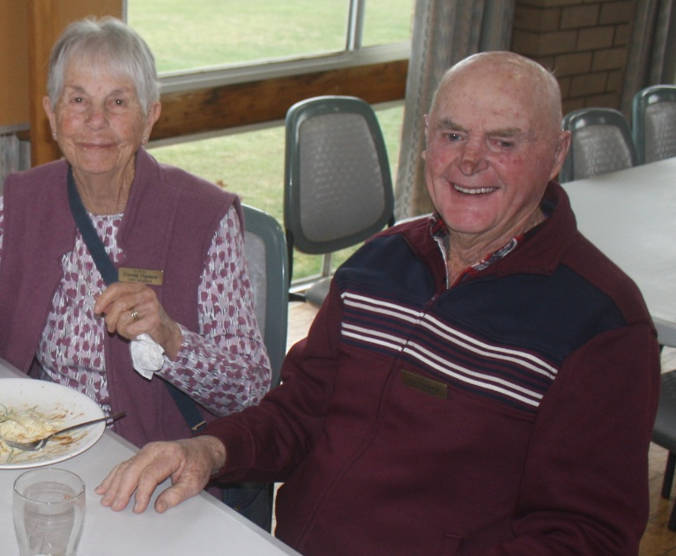

## Technology

"Cars today have too many technical gimmicks. I tried to drive in reverse, and a video played showing someone being run over by a car."

## Ever heard of Health and Safety?

No Safety Boots, really?



# The Minerva Story

Minerva classic cars are highly prized luxury vehicles originally made in Belgium, famous for their innovative engineering, aristocratic clientele, and striking coach-built bodies.

**History and Key Models**

* **Minerva was Belgium’s flagship marque** in the early 20th century, building luxurious automobiles often for royalty and industry leaders. What set Minerva apart was its use of the advanced Knight sleeve-valve engine—this lent the cars silent operation and longevity.
* Notable Minerva classics include the **1925 Minerva AD type**, which is currently being restored at the Club by Ian Baker and his helpers Neville and others.
* Larger luxury models like the **1930 Minerva AK** featured custom coachwork, such as the one-off Hibbard & Darrin convertible sedan found in the U.S. after decades in barn storage and covered in the TV show "Chasing Classic Cars".

**Engine and Technical Features**

* Most sought-after Minerva vehicles feature the **Knight sleeve-valve engine**—either straight-six or straight-eight configurations, depending on model and year.
* These engines are especially renowned among collectors for their quiet operation and resilience, distinguishing Minerva classics from other luxury marques of the era.

**Cultural and Collector Interest**

* Minerva cars appear in classic car events, documentaries, and auctions, especially when unique examples come to market after long-term preservation or restoration stories, like the 1930 AK featured on "Chasing Classic Cars".
* Collectors are drawn to Minerva's rarity, craftsmanship, technical innovations, and the mystique of their aristocratic heritage.

Minerva classics are true icons in historic motoring, representing a confluence of innovation, luxury, and exclusivity, making them highly desirable to collectors and enthusiasts worldwide.

The Minerva we have at the Club has an **AD series engine** which is a four-cylinder double sleeve-valve unit introduced around 1925, with a displacement of 2,255 cm³ and paired to a four-speed gearbox. It showcased Minerva’s commitment to advanced engineering in the vintage luxury segment.

**Key Specifications**

* **Type:** Four-cylinder, double sleeve-valve (Knight system).
* **Displacement:** 2,255 cm³ (2.26 L).
* **Power Output:** Approximately 15.9 hp (as cited for contemporary Minerva AD Sports models).
* **Transmission:** Four-speed manual.
* **Production Era:** Circa 1925 Vintage-era Minerva models.

**Signature Features**

* The use of the **double sleeve-valve** design provided exceptionally quiet and refined operation, a hallmark of high-end Minerva engines.
* These engines were recognized for their smoothness and reliability but were complex and expensive to produce, targeting the luxury car market segment.
* The 2.26 L engine was typical of Minerva’s post-WWI drive to produce both large and “smaller” luxury cars that retained technical prestige.
* Minerva AD cars, like other models of the period, were favoured by royalty and society elites and often included bespoke features and advanced mechanical systems.

Minerva’s AD series engine remains notable for its **4-cylinder sleeve-valve design** and robust, smooth-running characteristics, representing an important chapter in European luxury automotive history.

The 1925 Minerva AD sleeve-valve engine’s most common **failure modes** surround its unique double sleeve-valve system and lubrication design, with maintenance practices demanding strict attention to oil quality and frequent adjustments.

**Minerva Four-Cylinder Models (1920–1929)**

* **20CV (1920)**
  + 3.6-litre four-cylinder sleeve-valve engine.
* **15CV (1923)**
  + 2-litre four-cylinder sleeve-valve engine, introduced as a smaller and more affordable offering.
* **Type TT (1922)**
  + Four-cylinder sleeve-valve engine under 2 litres, positioned as the entry-level model in the early 1920s.

**Notable Points**

* All these models featured Minerva’s quiet, reliable sleeve-valve technology.
* From about 1924 onward, Minerva increasingly focused on larger six-cylinder and eventually straight-eight luxury cars, so four-cylinder production was limited as the decade progressed.
* There is no evidence of additional four-cylinder passenger car models in the mainstream Minerva lineup after the mid-1920s, until the short-lived 2-litre M4 model in 1934.

These models formed the backbone of Minerva’s mid-size luxury car lineup for the first half of the 1920s before the brand shifted its focus to six-cylinder and straight-eight powerplants.[wikipedia+3](https://en.wikipedia.org/wiki/Minerva_(automobile))

**Sleeve-Valve Operation (per the Bristol Hercules Radial Engine)**

The sleeve valve replaces conventional poppet valves. It has ports cut into its surface that align with cylinder wall openings as it rotates and moves up and down.

Each sleeve is actuated by helical gears and a linkage from the crankshaft, synchronizing its movement with the piston's position and engine cycle.

When the piston approaches the intake stroke, the sleeve port aligns with the intake passage, letting the air/fuel mixture in. On the exhaust stroke, the sleeve rotates and reciprocates to bring the exhaust port into line with the exhaust channel.

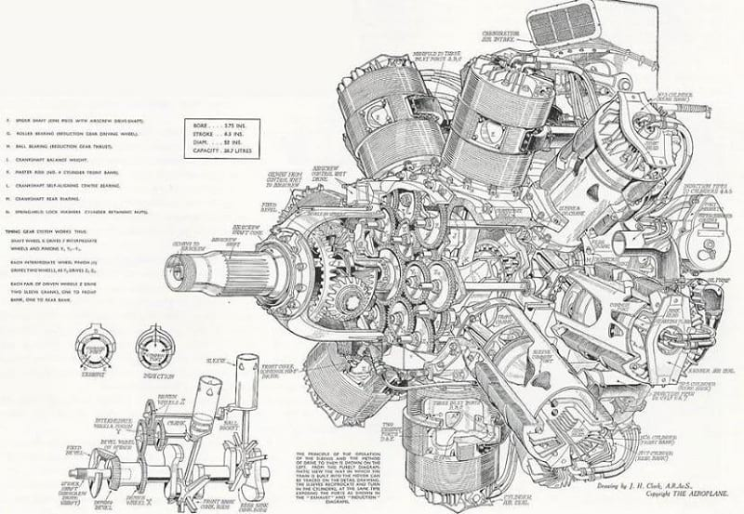

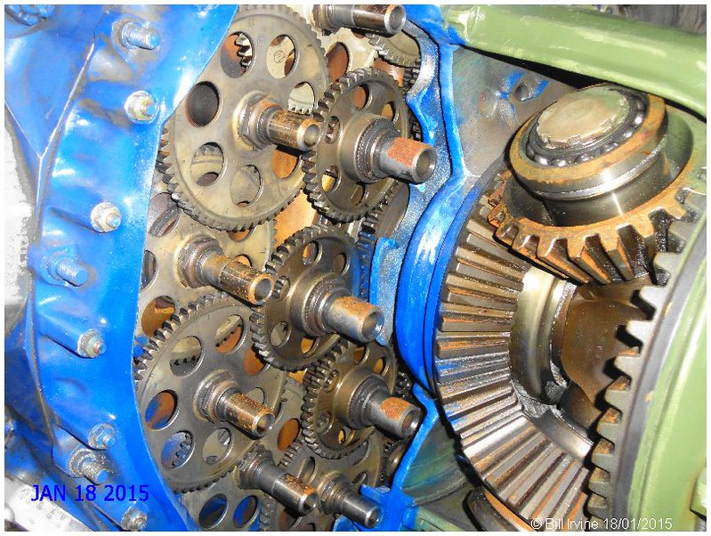

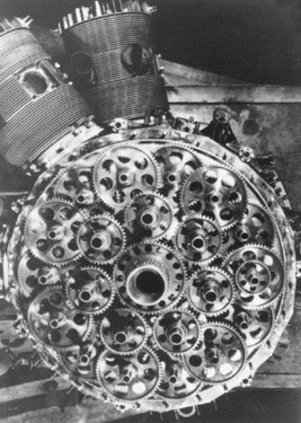

Operating principle of the double sleeve-valve engine