
Newsletter No. 33 - September 2025

High Country Run to Delegate

We had an entertaining High-Country Run on Father’s Day the 7th of September starting from the Club House to Delegate. Our first stop was Bombala which, to everyone’s surprise - including locally born Fred Silk - was bustling with activity. A number of shops were open, as well as the fabulous “Kitchen Eighty-Ate,” where we enjoyed a good cup of coffee.

With some time to spare, Euan - who clearly knows Delegate well - led the convoy on a sightseeing tour of the town. Right on schedule, we arrived at the Country Club at 12 noon for a buffet luncheon. There we met with true locals Allan Lindsay and the Hepburn’s, who are also members of the SCHVC.

Those in attendance included Pamela Summerell and Craig Ruting, Robyn Vella, Euan and Selina McKinnell, Rod and Cheryl Newman, Deirdre and Geoff Easton, Fred and Dinah Silk, Judy and Tony Stove, Sandy and Ken Coates, Louise and Neil Thiedeman, Dorothy and Jim Hepburn, Graham Fife, Allan Lindsay, Rhonda Sutton, and Walter Küng.

The Club extends its sincere thanks to the Delegate Country Club for its hospitality and for providing an excellent venue. The occasion provided both an enjoyable social gathering for members and an ideal opportunity to experience the scenic journey from the coast to the mountains.

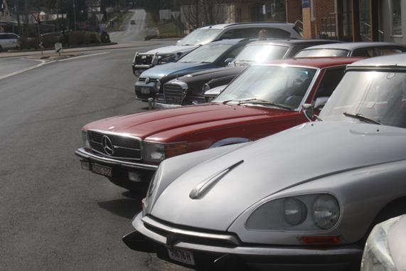 | 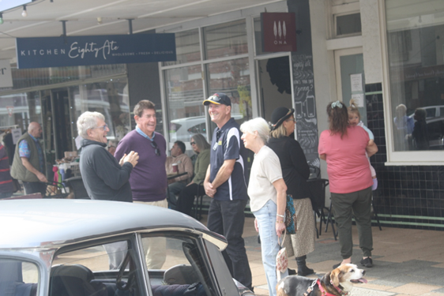
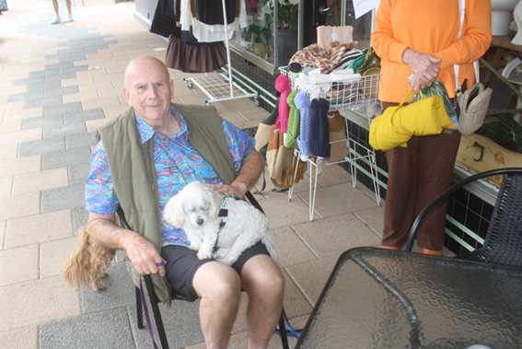 | 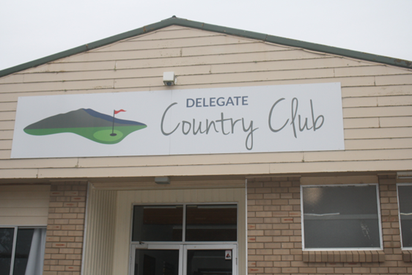
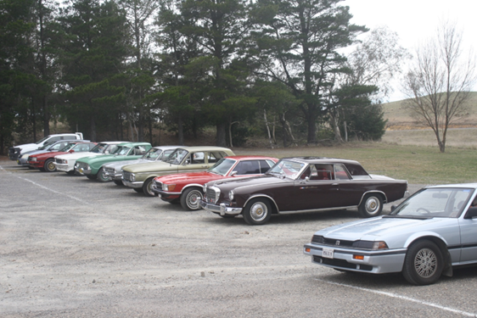 | 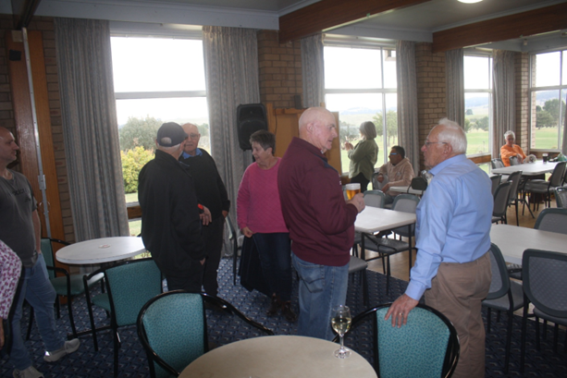
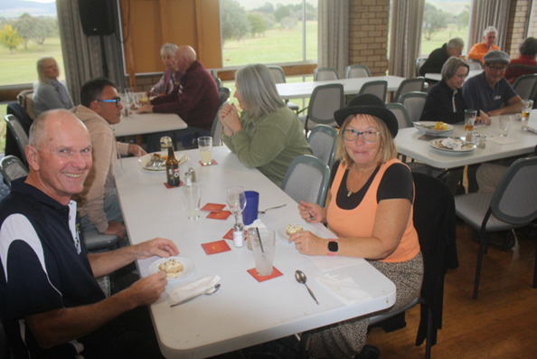 | 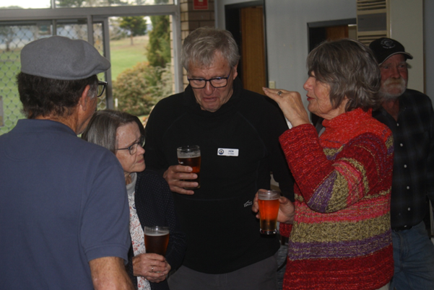
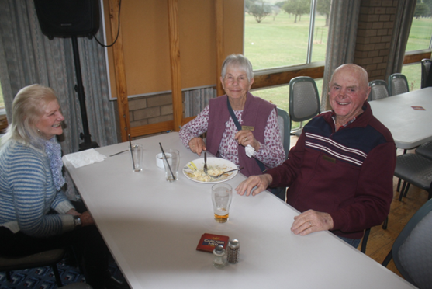 | 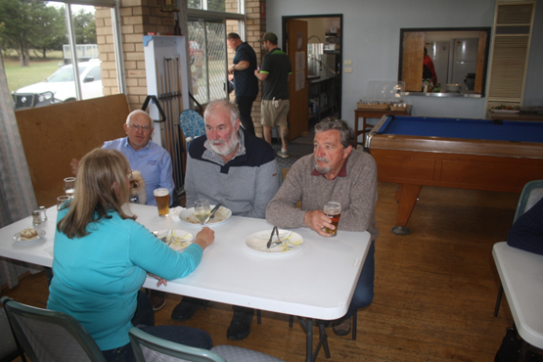
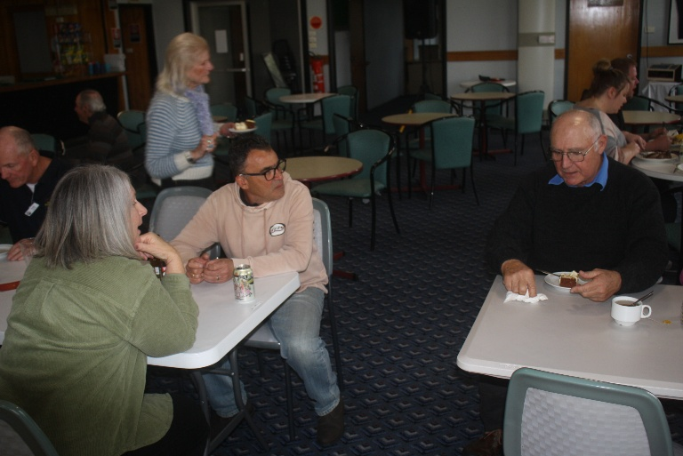 | 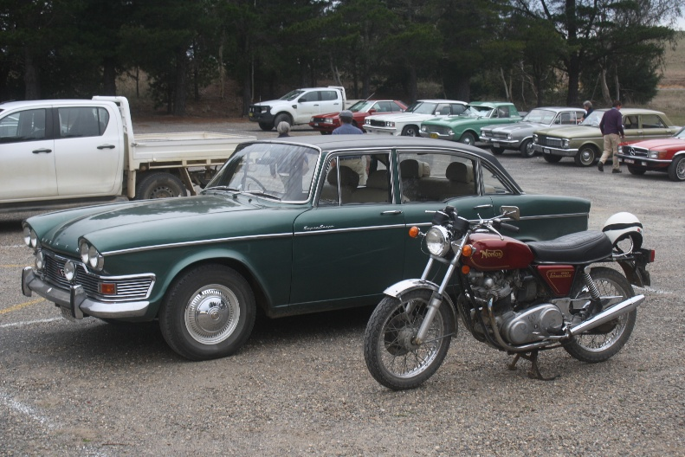

Please note:

The Minutes of the General Meeting dated 4th September are on our website and also displayed at the Club

Nomination Forms for committee positions in 2026 are attached to this email and are also available in hard copy format at the Club. Nominations are due 7 days ahead of the AGM i.e. on Thursday the 25th September. Please send to the secretary via email or post to PO Box 219 Pambula NSW 2549

Still time to join a few of us.
We’ll be leaving on the xx via Alpine Highway making our way to Adelaide. 5-day trip. Contact the Secretary for more info on accommodation, trip route etc.


