## **General Meeting**

You are invited to the SCHVC **General Meeting of 2025 on Thursday the February 6th, 2025.**

Be at the Clubhouse at 7:00pm for a prompt **start at 7:30 pm.**

Join us for the first General Meeting of the year, followed by a **Raffle, Snacks and Tea**

Please bring a plate to share.

Everyone is welcome, and we look forward to seeing you there!

***NOTE:*** Minutes of the last GM of December 2025 are displayed on the Club Rooms Notice Board and are also accessible on our website <https://www.schvc.com.au/>

## **Membership**

**Do not forget to renew your membership before the end of January!**

**Your car rego and insurance will have lapsed by 1st February should you not renew your membership!**

## **Membership Cards**

Due to the cost and past waste of uncollected 2023/2024 cards, we will only be printing 2025 Club membership cards for those that request them.

Please advise by email to [info@schvc.com.au](mailto:info@schvc.com.au) if you require.

Alternatively, you can also advise the Secretary at the February 6th club meeting or the Working Bee on the 8th. The cutoff date will be Wednesday the 10th of February. We will endeavour to get the Cards available at the March 6th General Meeting.

## **Help needed!**

The “Green Sheds” are being cleared up inside and out, also the structure requires reinforcing. Please contact Rodney Newman should you be willing to assist. Contact No. 0418 848 62. Your help will be greatly appreciated.

## **Recent Events**

Had a fantastic time at the Merimbula New Year’s Eve Market! Those community events are always so special, especially when you get to catch up with familiar faces. The Rotary Club was pleased with the turnout per below note:

*“ Hi Doug*

*A belated thank you to yourself and the Car Club for the great display of vehicles which added a great deal to everyone’s enjoyment of the NYE market.*

*Best wishes for 2025.*

*Regards*

*Bill Dejong”*

|  |  |
| --- | --- |
|  |  |
|  |  |
|  |  |

## **The Candelo Show**



Eight cars were invited by the Show Committee and 11 did showed up, thanks for everyone attending, always a good event to partake in -even without your classic or historic vehicle.

Some History - Since the inaugural Candelo Show in 1883, there have been three occasions when the event was not held. The 1884 Show was not conducted as the Committee focused on acquiring official grounds, transitioning to the AH & DF Association, and organizing the 1885 Show. The 1919 Show was cancelled due to severe drought conditions prevailing at that time, and the 1952 Show was cancelled in response to the devastating bushfires that affected the entire district in February.

|  |
| --- |
|  |
| Three Rolls Royce’s, Lincoln, Morris, Riley, Torana, FJ Holden, V8 MG, Alfa Romeo 33, and a Farm Ute |

## **Birthday**

### Happy belated birthday wishes to Dorothy Hepburn who celebrated her 80th on January the 16th ! 🎉🌟 Trust your day was filled with joy, love, and wonderful memories, and wishing you many more happy years ahead. 🥳🌹

The latest SPOKE has been printed and sent by post to subscribers who wished to receive a hardcopy. An E-Copy is available on our website to read and/or download.

## **Classic Cars that faded into History**

The automotive world has seen many brands rise to fame, only to disappear over time. From luxury marques to innovative pioneers, these companies once dominated the roads and captured the hearts of car enthusiasts. In this article, we will explore 25 iconic car brands that have vanished from the market, leaving behind a legacy of memorable vehicles and a rich history in the world of automobiles.

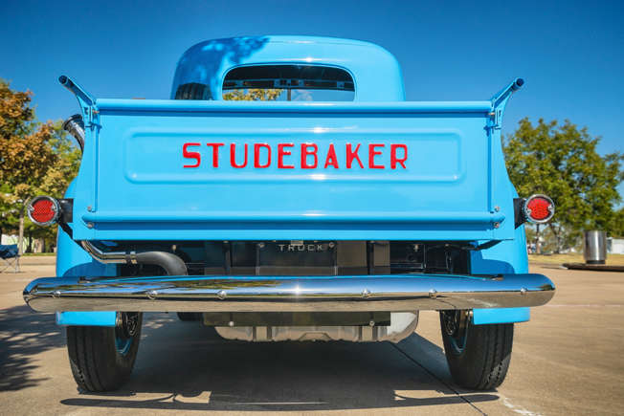**Studebaker** entered the automotive business in 1902 with [electric vehicles](https://en.wikipedia.org/wiki/Electric_vehicle) and in 1904 with gasoline vehicles, all sold under the name "Studebaker Automobile Company". The first gasoline automobiles to be fully manufactured by Studebaker were marketed in August 1912. Over the next 50 years, the company established a reputation for quality, durability, and reliability.

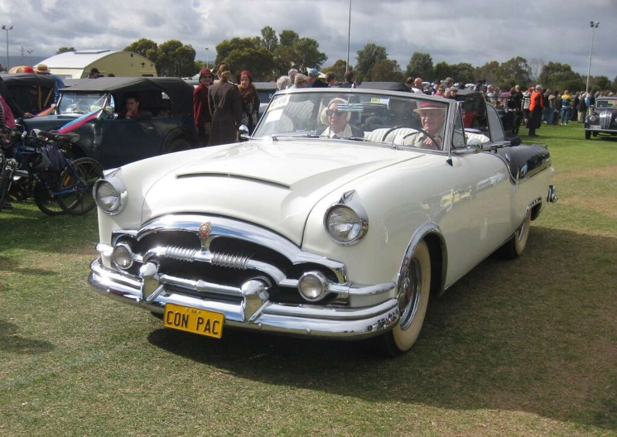**Packard**, synonymous with luxury and craftsmanship, produced some of the most opulent vehicles in the early 20th century. Known for the Packard Twelve and its advanced engineering, the brand could not withstand post-war economic challenges and merged with Studebaker, eventually ceasing operations in 1958.

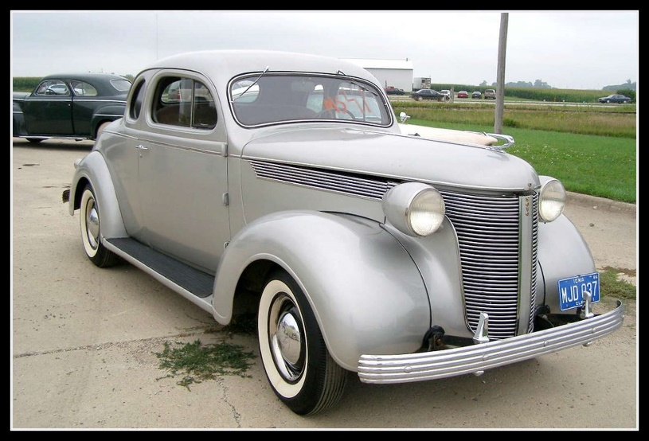**DeSoto**. A Chrysler brand established in 1928, DeSoto was celebrated for its stylish and powerful cars like the Fireflite and Adventurer. Despite its popularity, Chrysler discontinued DeSoto in 1961 due to declining sales and market overlap with other Chrysler brands.

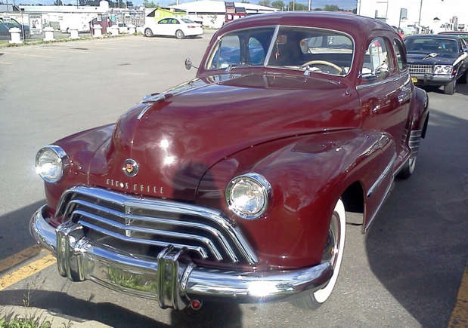**Oldsmobile** Founded in 1897, Oldsmobile was one of America’s oldest car brands, known for pioneering innovations like the automatic transmission. Models like the Cutlass and 442 became icons. General Motors phased out Oldsmobile in 2004 due to declining sales and market restructuring.

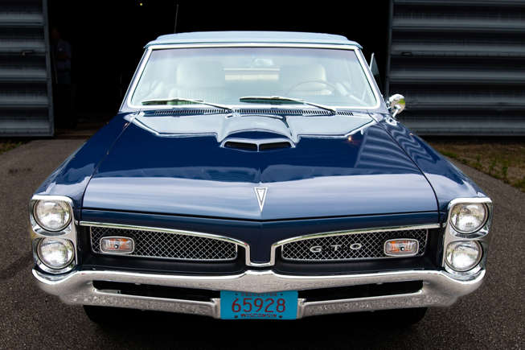**Pontiac**, known for its performance-oriented cars like the GTO and Firebird, was a beloved brand under General Motors. Despite its popularity, GM discontinued Pontiac in 2010 as part of a broader effort to streamline its brand portfolio during financial difficulties.

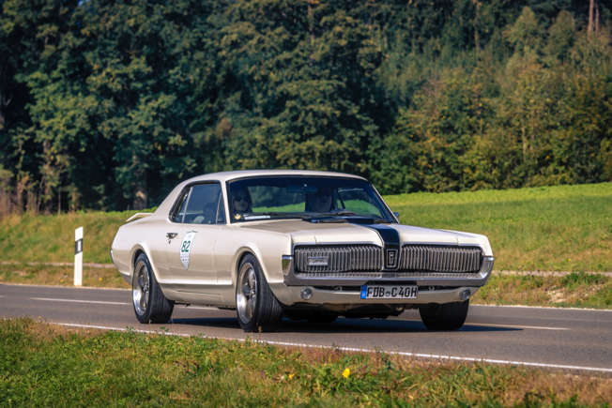**Mercury** - Ford’s mid-range brand, Mercury, bridged the gap between Ford and Lincoln with models like the Cougar and Grand Marquis. Established in 1938, Mercury aimed at a more upscale market but was discontinued in 2010 due to declining sales and market realignment.

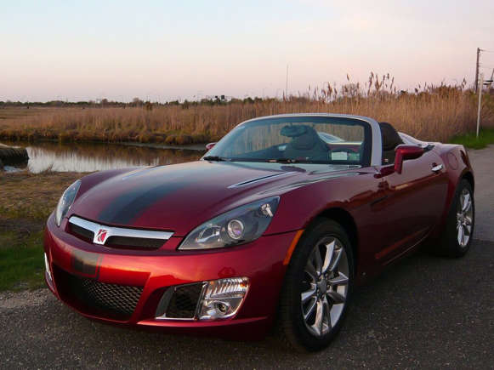**Saturn**, launched by General Motors in 1985, was known for its no-haggle pricing and customer-centric approach. Models like the S-Series and Vue gained a loyal following. However, GM ended Saturn in 2010 amid restructuring efforts during the fiscal crisis.

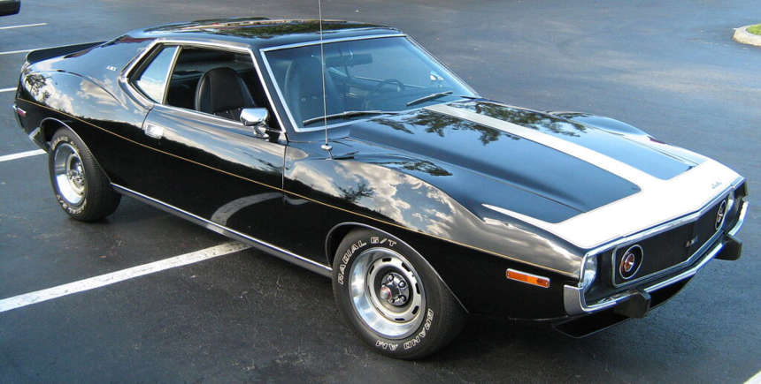**AMC (American Motors Corporation)** - Formed from the merger of Nash and Hudson in 1954, AMC was known for innovative compact cars and the rugged Jeep. Despite successes like the Gremlin and Pacer, AMC was acquired by Chrysler in 1987, and the brand was eventually phased out.

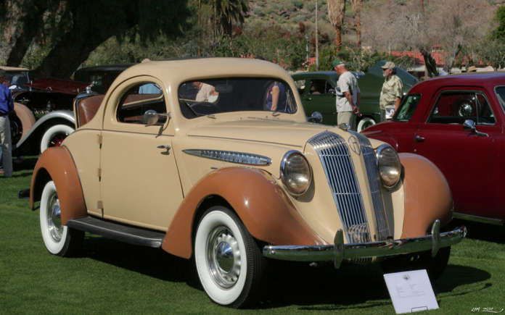**Hupmobile**, founded in 1909, gained fame for its affordable, reliable cars. The brand’s popularity peaked in the 1920s but could not survive the Great Depression and competitive pressures, leading to its closure in 1940.

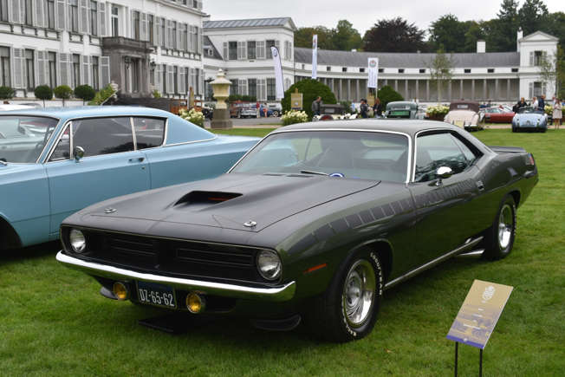**Plymouth** - Launched by Chrysler in 1928, Plymouth offered budget-friendly, reliable cars like the Barracuda and Road Runner. Despite its success, Plymouth was discontinued in 2001 as part of Chrysler’s efforts to focus on its other brands.

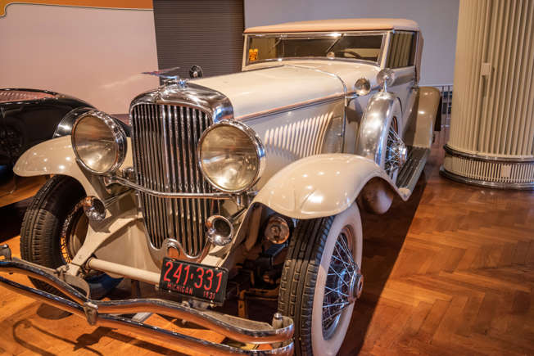**Duesenberg**, established in 1920, was the epitome of luxury and performance, producing some of the most advanced and elegant cars of the era, like the Model J. The Great Depression and high production costs led to its closure in 1937.

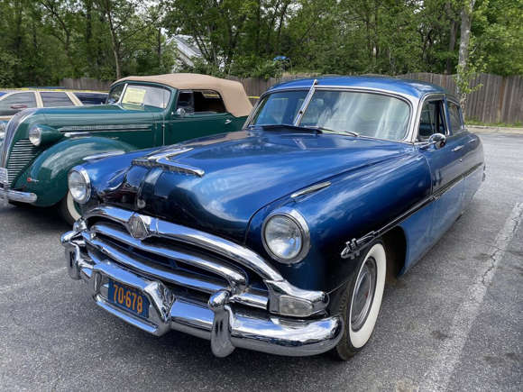**Hudson**, known for its innovative designs and engineering feats, produced notable models like the Hornet. Merging with Nash-Kelvinator to form AMC in 1954, Hudson’s brand identity faded as AMC focused on its own lineup.

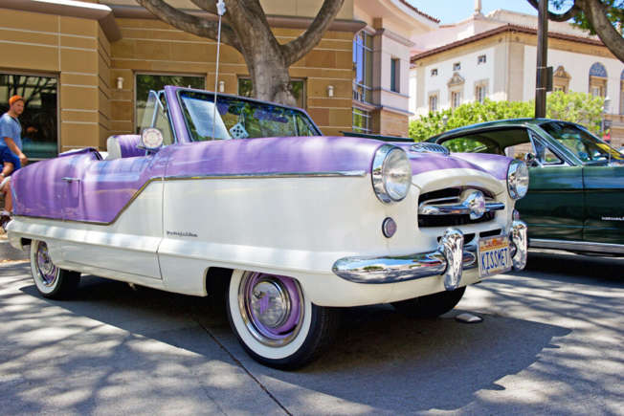**Nash**, famous for compact cars and early adoption of unitary construction, merged with Hudson to create AMC in 1954. The brand was known for models like the Nash Metropolitan before being absorbed and phased out by AMC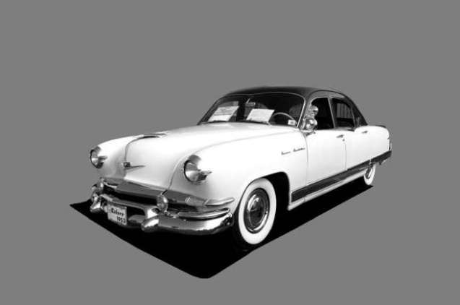**Kaiser**, which emerged post-WWII, was known for its stylish and innovative cars, including the fiberglass-bodied Kaiser Darrin. Merging with Willys-Overland in 1953, Kaiser’s passenger car production ended in the mid-1950s.

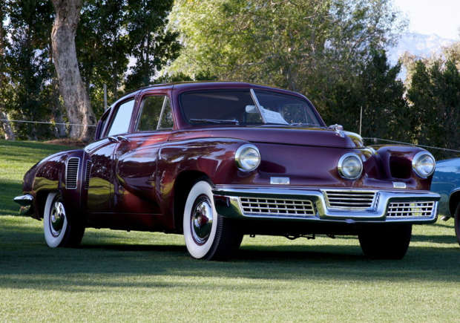**Tucker** is legendary for the Tucker 48, a car with revolutionary safety features and a rear-mounted engine. Despite its innovative design, only fifty-one cars were produced before the company faced legal and financial troubles, leading to its closure in 1949.

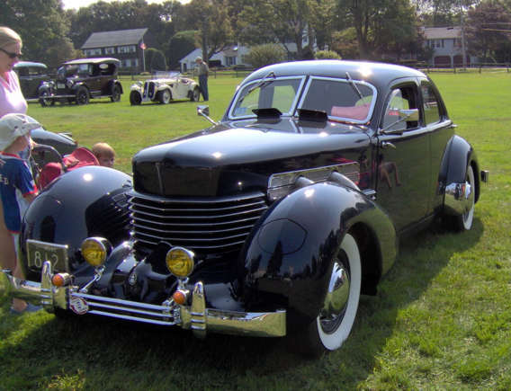**Cord**, known for its visually striking and technologically advanced cars like the Cord 810 with front-wheel drive and hidden headlights, ceased operations in 1937 due to financial difficulties.

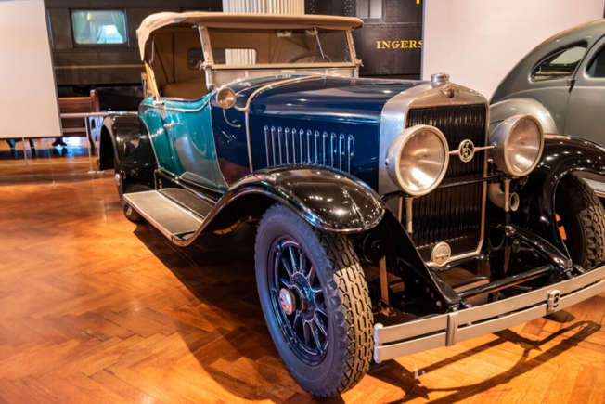**LaSalle** - A Cadillac companion brand, LaSalle offered luxury vehicles at a slightly lower price point. Known for elegant designs by Harley Earl, LaSalle was discontinued by General Motors in 1940 to streamline its offerings.

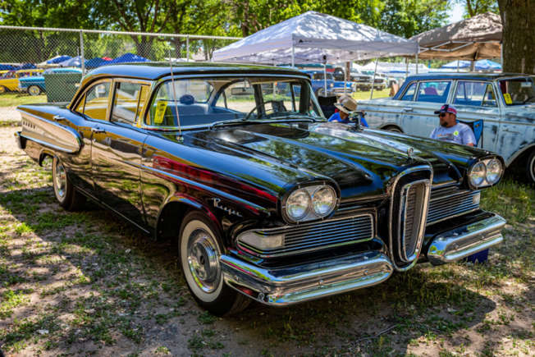**Edsel** - Launched by Ford in 1958, Edsel was aimed at filling a market gap but became famous for its marketing and design missteps. The brand was discontinued in 1960 after only three model years due to poor sales and negative public perception.

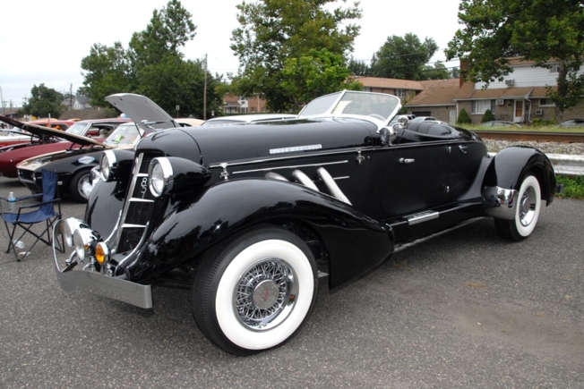**Auburn** produced elegant and high-performance cars in the 1920s and 1930s, including the Speedster. The Great Depression severely impacted sales, leading to Auburn’s closure in 1937.

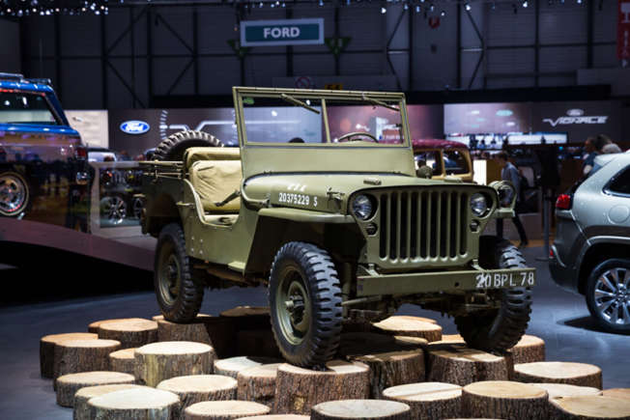**Willys** - Best known for producing the original Jeep during WWII, Willys played a crucial role in automotive and military history. Merging into Kaiser Motors, the Willys brand eventually disappeared as Jeep became its own identity.

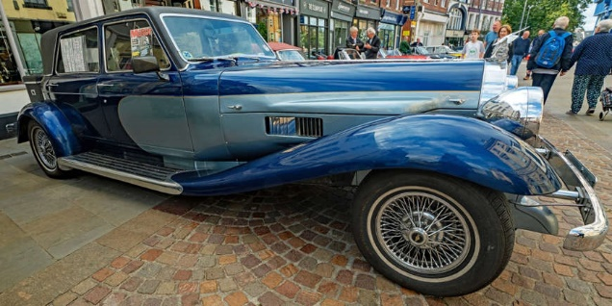**Panther** -Westwinds, known for luxury and performance cars like the Panther De Ville, struggled financially and ceased production in the early 1980s despite its unique and opulent designs.

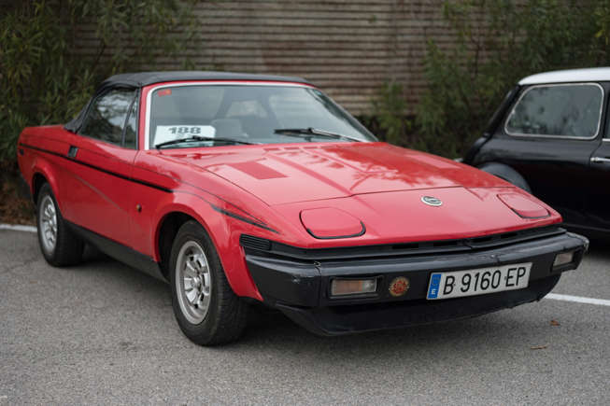**Triumph** - A British marque, Triumph was famous for its sports cars like the TR series. The car division was merged into British Leyland and phased out in the early 1980s due to financial difficulties and industrial strife.

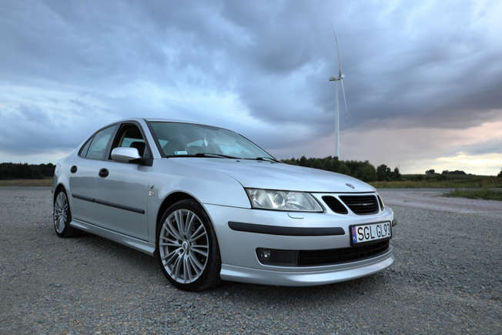**Saab**, originally an aircraft manufacturer, became known for its quirky, safety-focused cars like the 900 and 9-3. Financial troubles led to its sale to General Motors, and eventually, Saab was discontinued in 2011.

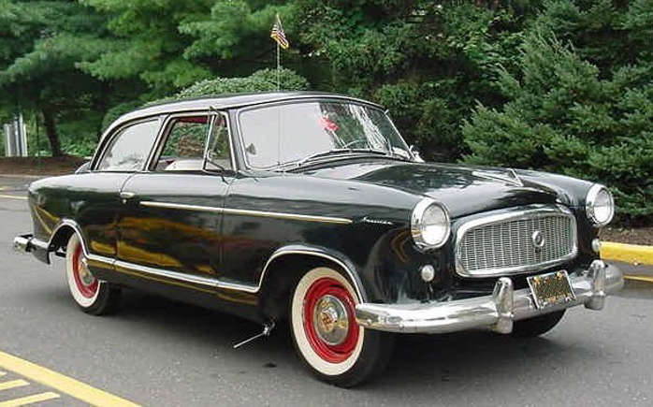**Rambler** - Initially a model under Nash, Rambler became its own brand known for compact, economical cars. It was absorbed into AMC in the 1960s, which eventually phased out the Rambler nameplate.

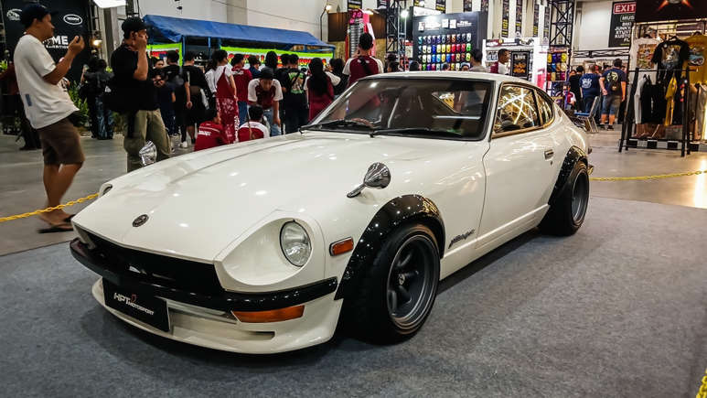**Datsun** gained international fame in the 1970s for its affordable and reliable cars, including the 240Z sports car. Rebranded as Nissan in the 1980s, Datsun was later revived as a budget brand in select markets but retains its iconic legacy.