-+

SEPTEMBER 2025



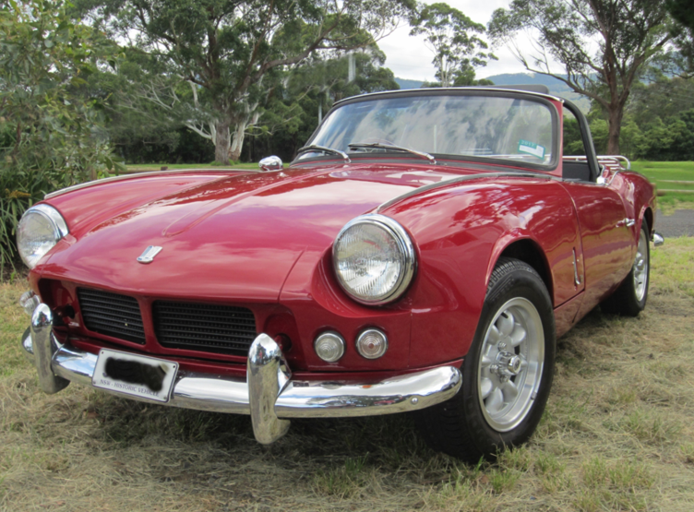

1962 Triumph Spitfire Bob Harwood

P.O. BOX 120 SHELLHARBOUR CITY CENTRE, N.S.W. 2529

Website: www.illawarravintagecarclub.com

Email: illawarravintage2025@yahoo.com.au



P O Box 120
SHELLHARBOUR CITY CENTRE
NSW 2529

Reg No. Y2064930
ABN No.59 048 511 460

SEPTEMBER 2025

IVCC CONTACT NUMBER: 0430 916 081

COMMITTEE
President/Publicity Officer/Plates Registrar Ron Hillard 02 4272 4120 0411 724 120

Vice President /Treasurer Tom Irvine 0433 916 267

Secretary/Public Officer Dianne Irvine 0430 916 081

Minutes Secretary Carol Hillard 02 4272 4120
0411 724 120

COMMITTEE POSITIONS

Committee person 1, Plate Registrar Gary Harrison 02 4256 4308

Committee person 2, Trip Organiser Marie Laughton 0481 720 229

Committee person 3 John Fletcher 0407 704 853
Committee person 4, Uniform & Regalia Officer Brenda Fletcher 0407 704 853

NON-COMMITTEE POSITIONS

Plates Registrar Paul Blanksby 0403 701 788

Editor VACANCY

Send magazine articles to illawarravintage2025@yahoo.com.au

SOCIAL COMMITTEE

Suppers/Catering John Fletcher 0407 704 853
Brenda Fletcher 0407 704 853

Welfare Dianne Irvine 0430 916 081

Raffles Marie Laughton 0481 720 229

CLUB BANK DETAILS:
BSB 062 528 Account number 1029 9383
Reference: Your surname & event/membership

ILLAWARRA VINTAGE

COMING EVENTS AND CONTACT NUMBERS:
Phone numbers and contact names in the front of the magazine ar e for members to use if they wish any further details about the event and/or if on the day of the event the weather looks doubtful. It is up to each member to make contact and check as it is not up to the organiser to ring members.
Contacts are Marie Laughton or Ron Hillard
phone numbers on page one.
If you want to attend an outing of a club that you have listed as a secondary club on your 1259 form, please either notify the daybook co-ordinator or have it minuted at a meeting.
If you want to attend an outing organised by a club that you are not a member of then please make sure you have an invitation from that club and this invitation has been minuted by this club.

Meetings: Normally are held every third Wednesday in the Laurel Room, Heineger House, Ribbonwood Centre, Dapto at 7.30pm.
Committee meetings are usually held the first week of each month. If you wish to discuss anything with the committee, please see Secretary Dianne Irvine to arrange this.
Opinions and comments in this magazine are not necessarily those of club members, the committee or editor.

CLUB UNIFORMS & REGALIA

Polo Shirts and Jackets can be ordered individually from the club.
Contact the Uniform Co-ordinator


Sew on patches $ 9.00
Lapel Badges $ 6.00
Car Name Bars $30.00 per pair
Peak Caps $12.00
Car Badges $24.00
Name Badges $12.00

Happy Birthday to our Members
Celebrating in August!
Phil Holdup
John Fletcher

Joke of the Month!

What do you call a paper airplane that doesn’t fly?

Stationery

PLEASE SUPPORT OUR ADVERTISERS AND ADVISE THEM YOU ARE FROM IVCC
ILLAWARRA VINTAGE 3 SEPTEMBER 2025

Motorkarna and rocker
cover races

Saturday October 17th 2025

Dons Farm 560 Avondale Rd, Avondale 9:30am
BYO morning tea and lunch

Presidents Run
Saturday 25th October
Details announced soon

Melbourne Cup Day

Tuesday 4th November at Marie’s house
3-32 Mattles Way Bomaderry
Lunch provided @ cost of $15 a head.
Let Marie know if you’re coming

SCVCC Run around the lake
Sunday 9th November
Join South Coast Vintage car club for Fish ‘n’ Chips.
Meet at Berkley Fish ‘n’ Chip shop at 10:00am

General Meeting

Wednesday September 17th at 7:30pm

Laurel Room, Heineger House,
Ribbonwood Centre, Dapto

Robertson Picnic BYO
Wednesday 24th September
Meet at Albion Park
Opposite Bowling Club
9:15am for 9:30am

Berkley Picnic BYO
Saturday 4th October
Meet at William Beach Park
9:15am for 9:45am start
BBQ available

PLEASE SUPPORT OUR ADVERTISERS AND ADVISE THEM YOU ARE FROM I.V.C.C.


Specialised Brake Solutions

- Full range of brake and clutches

- Disc and drum machining

- Flywheel grinding

- Bonded shoes

- Hoses – rubber and braided

- Brake pipes made to order

Need advice on your brakes or clutch for your Classic or Vintage restoration? Talk to us.

Phone: 4226 9996
104 Auburn Street
Wollongong

Email: brakepro4@gmail.com

Members!

Please keep track of all the trophy runs. A lot of work goes into these runs. We would really appreciate your support.

JOE – M: 0412 064 620
Free quotes for any General Home Maintenance and Odd Jobs

In short, any “ODD JOB” that’s too small for

In short, any “ODD JOB” that’s too small for a builder or tradie but too big for you, call ME!
oddmanjoe61@gmail.com
ABN: 95067789529 Insurance: Public and Product Liability

ODD MAN OUT
GENERAL HOME MAINTENANCE

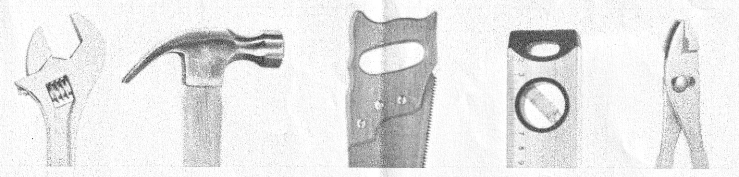

- Minor Plumbing/Electrical
- Repair/build – Garden sheds, Chook runs, Dog kennel, Cubby house
- Gyprock repairs
- External and Internal painting
- Timber/Colourbond fence build or repair
- Door or Window repair
- Hang Pictures/Paintings
- Repair or Restore Timber;
Decks, Paving, Doors, Door jambs,
Door Handles and locks
Architraves, skirting boards
- Small Brickwork, Wood Sleeper Walls

ILLAWARRA VINTAGE 5 APRlL 2025

RIGHT PART RIGHT PRICE – FOR 2WD & 4WD
Over 25 Years’ Experience in The Industry
• Service •Underbody •Electrics •Electronics • Exedy Clutches & Brakes
• Standard & Performance Parts
138 INDUSTRIAL RD, OAK FLATS Phone: 4256 3366
100 KENNY ST, WOLLONGONG Phone: 4229 9178
www.wollongongautosupplies.com.au

SERVICING THE ILLAWARRA FOR OVER 25 YEARS



• Quality New Tyres • Big Range of White Wall Tyres
• Passenger • Light Truck • 4 Wheel Drive
• Wheel Alignment • Rego Checks
• Logbook Service
246 Shellharbour Rd
WARILLA NSW 2528
Ph: 4240 5900

78 Princes Hwy
CORRIMAL NSW 2518
Ph: 4249 1900
• Brakes and Suspension Repairs

Mon – Fri 8am – 5pm
Sat 8am – 2pm

24 HR ACCIDENT & BREAKDOWN ASSISTANCE
Proudly Servicing the Illawarra
Private & Commercial Transport Solutions


Container & Site Shed Specialist

8.5m Tray - 11 Tonne Carrying Capacity

• Insurance Towing
• Bluescope Access

• Wreck Removal
• General Transport
• Fully Insured
• Oversize Loads
• Tilt Tray Service
• Machinery & Equipment
• Caravans, Boats, Bikes
• Heavy Trucks
Lic. 11006
Fixed Price
Quotes & Advice

QUICKHITCH
TOWING & TILT TRAY SERVICES

Phone: (02) 4257 7577
QUICKHITCH AFTER HOURS: 0427 577 777
Email: quickhitchtowing@bigpond.com
ILLAWARRA VINTAGE 7 September 2025

Shannon's Sydney Classic 17/08/2025
Attendees were Matt Cox, his brother in law and daughter (Centura), Garry Harrison (Austin Healy), Tom and Dianne Irvine. (S type Jaguar).
We met at 7.15am at Mt Ousley.
It was freezing cold there. It is every time I go there!
Garry had the top down on his car but had a change of heart when he realised just how cold it was and put the top on before we left Mt Ousley.
After this was accomplished, we set out for Eastern Creek.
However, by the time we got to Eastern Creek the weather had started to
warm and by 11.00am it was a beautiful sunny day.
We had morning tea a short time after we arrived and then set out to explore. There were some beautiful exhibits there!
Many beautiful cars from a bygone era that had been lovingly (and expensively, no doubt) restored to their former glory.
We wandered around and enjoyed looking at all the cars then returned to the place where we were parked which was a long way from the main track area, but it was quite nice when you finally arrived back there.
We then had lunch and sat and chatted until it was our turn to drive around the track (1.40pm).
After that we set our goodbyes and headed home.
It was a very enjoyable day, and I would encourage others to think about going next year. I know it is a fair way to travel but I consider it is worth it.
If you are thinking about going next year, please tell me as soon as you decide so I can order tickets early. Maybe by doing that we may get parked closer to the track area.
PLEASE SUPPORT OUR ADVERTISERS AND ADVISE THEM YOU ARE FROM I.V.C.C.
ILLAWARRA VINTAGE 8 September 2025

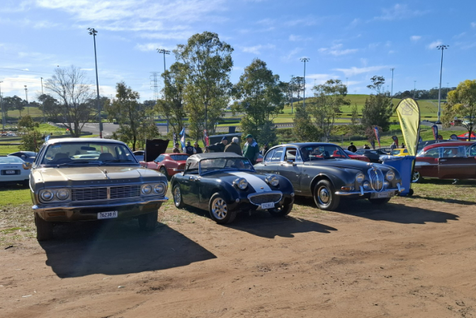

Matt Cox, Garry Harrison and Tom and Dianne Irvine’s cars at Eastern Creek.

Story by Dianne Irvine

NSW Seat Belt Detection

Seat beat detection cameras are now operating across NSW. The cameras detect if drivers or passengers are wearing seat belts.
So What does this mean for historic or classic cars that may not have seat belts fitted?
NSW transport will consider whether the vehicle complies with Australian Design Rules (ADR). This means fines will not be applied for cars fitted with lap seat belts or no seat belts at the time of manufacture.
For further information see the Transport NSW website.

PLEASE SUPPORT OUR ADVERTISERS AND ADVISE THEM YOU ARE FROM I.V.C.C.

ILLAWARRA VINTAGE 9 September 2025
Birthdays for Special club members

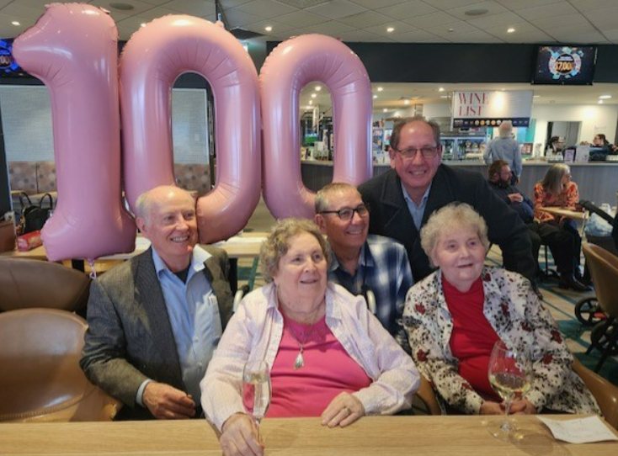
Club Legend Marj Tweedie celebrating her 100th birthday last month with family and friends.

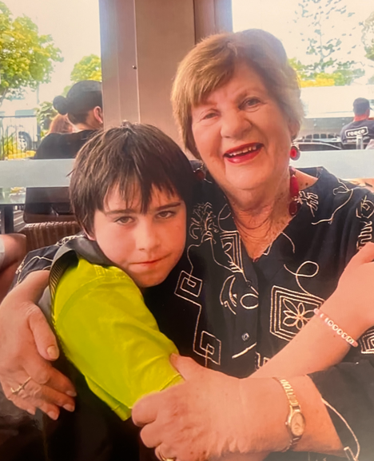
A happy birthday was celebrated by Betty Visman last month

PLEASE SUPPORT OUR ADVERTISERS AND ADVISE THEM YOU ARE FROM I.V.C.C.

ILLAWARRA VINTAGE 10 September 2025
Solar World Challenge
Once again, the World Solar Challenge was run this year. Its a bi-yearly event meaning its run once every 2 years. 2025 was different for several reasons. Firstly, it was set 2 months earlier than usual running in August instead of October. Secondly there were rule changes with the battery size and the size of the solar panels.
To recap, the event is to push the limits of solar technology and innovation. Teams must travel 3021km from Darwin to Adeliade using purely solar energy to power their vehicle. On the journey the teams must stop at 11 control points where they must spend 30 mins. During this time only the driver can touch the vehicle. Normally they align the solar panels so that they can charge their battery during the 30 min stop. Start time is 8am. Stop time is 5pm. It usually takes 4 to 5 days to complete the distance.
This is a global event so many teams from around the world attend. As usual there was a large presence from European countries. Multiple Dutch and German teams participated. As well as Asia and America. Australia had several teams from multiple states. I should mention these teams are represented by universities with the actual team members mostly comprising of students.
In 2023 the winning Belgium team was Innoptus and they introduced and used a fin / wind sail. As they won the event this feature did not go unnoticed, so in 2025 4 teams incorporated fins. All 4 teams had a fin that could retract behind the driver’s seat, although I could not verify this with the Hungarian team. However, one Dutch team, Brunel, decided to go with 2 fins. The second and much larger fin had to be manually installed by the driver whilst the car was stopped. It was nicknamed the sword fin.
2025 race was the closest event I have participated in and I have been involved since 2005. The top 3 teams often within a minute of each other even after 2500km! The next 7 teams were only 75km apart. The biggest drama was at the last control stop in Port Augusta. Team Brunel was in first with a 3 minute 5 second lead. At 25 mins into their stop the driver was observed installing the large sword fin. This was the first and only time it was deployed on the whole challenge.
PLEASE SUPPORT OUR ADVERTISERS AND ADVISE THEM YOU ARE FROM I.V.C.C.

ILLAWARRA VINTAGE 11 September 2025

However, that wasn't the most dramatic point. As they drove out of the control point, they pulled over and proceeded to change the driver’s side front tyre. Time was ticking down. Each second meant the second team, team Innoptus from Belgium, would be reducing the gap between 1st and 2nd. Somehow Brunel, replaced the tyre before Innoptus left the control stop, but they were immediately behind. The gap was literally seconds!
My roll is to document via video and photos all the teams and excitement for event organisers. So we would stop in front of cars and film as the drive by. We often over take them many times over the duration of the challenge to be in ideal positions for filming. In this situation we sat behind the 2 lead teams. Why? We wanted to film the overtake attempt.
Now in an ordinary car overtaking we just do. But consider this. The solar car convoy has 3 cars. The pilot which is a normal car, the solar car followed by a normal chase vehicle. Any over taking needs to consider this extra time and distance for the convoy to pass. We waited for this to happen but both teams were right up at the speed limit of 110km/h and with only 35 mins until 5pm it never happened. But they set up camp on side of the road, less then 1km apart. Thats after 2750kms.
The last day was to be an exciting event, but alas this did not happen. The day before clouds and rain came in and really disrupted the ability for the cars to charge. So much so Innoptus had depleted their battery. They had to wait around 45 mins to charge their battery, to provide enough energy to reach the finish line. During this time, team Twente overtook and moved into second place. Brunel won the 2025 race. Then Twente followed by Innoptus.
Story by Guy Kempny

PLEASE SUPPORT OUR ADVERTISERS AND ADVISE THEM YOU ARE FROM I.V.C.C.
ILLAWARRA VINTAGE 12 September 2025

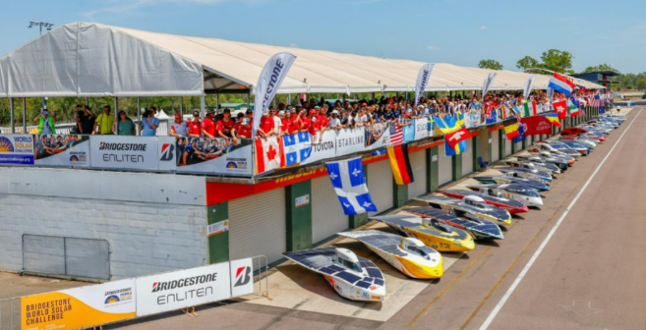

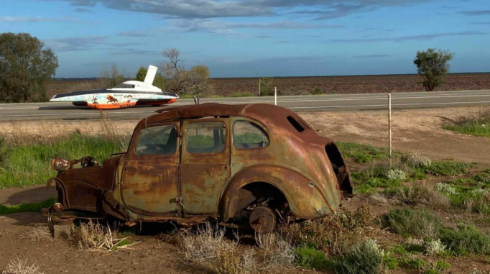
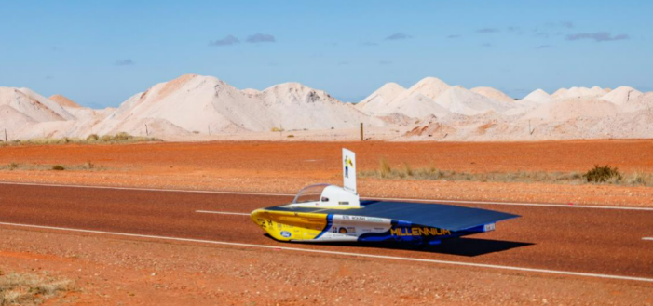

PLEASE SUPPORT OUR ADVERTISERS AND ADVISE THEM YOU ARE FROM I.V.C.C.


www.industrialsupplies.com.au

- ABRASIVES & REPAIR COMPOUNDS
- AUTO SEALANTS
- RUST CONVERSION & FISH OIL PRODUCTS
- EYE MATCH SPECIALIST
- SPECTROPHOTOMETER ON SITE
- ALL AUTOMOTIVE PAINTS
PHONE: GAVIN TELFORD
4271 3888 or 4271 7032
Email: gavin@industrialsupplies.com.au

8-10 THIRD AVENUE
UNANDERRA
‘Tuning Par Excellence’

Specialising in …
• Electronic Fuel Injection • Carburation
• Using the latest High-Tech test equipment
• Large range of spare parts for tuning
• Mercedes & SAAB

TONY HUTCHISON
PROPRIETOR

2/10 MARSHALL STREET
DAPTO NSW 2530

Phone: (02) 4262 2355
Fax: (02) 4262 2011


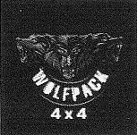



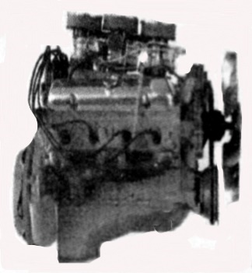
Ph 4257 7780 Mob 0417 023 601

Email: pkheadservicing@gmail.com

30 Veronica St Warilla



Brad Yates
Managing Director

2/8 Shaban St Albion Park Rail
info@oakflatsmufflermen.com.au

Les Pali
Panel Beater & Spray Painter

Phone:
0403 016 180

Specialising in minor dent, paint and
rust repairs

